Ministry of Science and Higher Education of the Russian Federation

Federal State Budgetary Educational Institution

of Higher Education

«Ufa University of Science and Technology»

Institute of Informatics, Mathematics and Robotics

Department of Computational Mathematics and Cybernetics

Information systems administration

Laboratory report № 1

Performed:

Students of the group PRO - 427 Polina Kasich

Polina Loginova

Adelia Shangaraeva

Ufa – 2023

THE CONTENT

The task 3

1 Theoretical part 4

1.1 CMS 4

1.2 Solving methods analysis 7

1.3 Web-servers analysis 10

2 Practical part 12

Bibliography 13

# The task

1. Form a working group, distribute roles, agree on the topic of the project, based on the following conditions:
   1. As part of the project, software must be created for the information system of a technical facility. Describe the main parameters of the object.
   2. The software must have a client and server part in the form of separate applications.
2. Creation of a project website with the following information pages:
   1. The main page of the working group.
   2. Working group projects – information about all past projects is displayed here.
   3. A page dedicated to the conceptual description of a technical object or information system. The following provisions of the TS should also be presented here:
      * Goals of creating the system
      * Basic functionality of the system
   4. Each project should have its own page reflecting the main results of the work or the progress of work. A description of the software used must be provided.
   5. Information about the members of the working group (role in the group, contacts, etc.).

# Theoretical part

## CMS

*CMS (Content Management System)* – is an affordable alternative to classic website development, thanks to which even a person far from knowledgeable about layout, scripts and CSS styles can create it. It involves scripts for generating and managing site content, “wrapped” in an intuitive graphical interface.

A CMS typically consists of two main components:

* a *content management application (CMA)* as the front-end user interface that allows the user to add, change, and delete content from a website without webmaster intervention;
* a *content delivery application (CDA)* that compiles the content and updates the website.

Main functions:

* providing tools for creating content, organizing collaboration on content;
* content management: storage, version control, access compliance, document flow management;
* publishing content;
* presentation of information in a form convenient for navigation and search.

CMS capabilities provided:

* the ability to implement full-fledged Internet resources by employees even without basic web development skills;
* convenient organization of taxonomy (categories, groups, sections);
* full-featured content editing module;
* simplification of web mastering procedures (site transfer, adjustment of indexing settings, mirrors, etc.) and settings of SEO attributes (NC, meta, etc.);
* ease of administration, while this function can easily be transferred to another employee; if necessary, it is enough to familiarize him with the interface and basic functions of the platform;
* efficiency of website creation and reduced development costs;
* the ability to use one of the many free or commercial design templates produced specifically for certain CMS (if compliance with the identity is not fundamental);
* community information support.

Table 1. Differences between CMS and CMF

|  |  |  |
| --- | --- | --- |
|  | CMS | CMF |
| Definition | (Content Management **System**) is software that helps manage website content. It allows you to create, edit and publish content, as well as manage users, settings and site design. CMS is a ready-made solution that provides an extensive set of functionalities. | (Content Management **Framework**) is a more flexible and customizable approach to managing website content. CMF provides developers with greater functionality when creating their own solution, which gives greater freedom in managing site content. However, this requires additional time and resources since creating a specific solution requires starting from scratch. |
| Functionality | A ready-made software designed for creating and managing websites. | A set of tools and libraries that allows developers to create their own CMS and adapt them to different projects. |
| Flexibility | Often have limited options for customization and expansion, and may be too heavy for some projects. | Developers can select only those components that are necessary for their project and integrate them into their system. |
| Difficulties in use | Quite easy to use and are usually intended for users without technical skills. | Requires considerable programming and web development knowledge, and experienced developers can use it to create more complex and customizable content management systems. |
| Cost | Have free and commercial versions with different costs and a set of functions. | Usually expensive, and their use requires highly qualified programmers. |

Basic concepts and terms used in the CMS for operation and operation:

1. Decor. In this section, you select a theme for the visual structure of the site. The main settings here are to enable/disable certain elements on the site pages: Logo Site name Slogan Menu Fonts, text color, etc.
2. Structure. There is a general structure for the appearance of sites. Here you can configure the placement of block content in side columns and other areas of the site. There are several standard block arrangements:
   1. Site header (page title)
   2. Site menu (navigation)
   3. Left/right column (additional information for the user)
   4. Content (main page content)
   5. Footer (signatures, contacts)
3. Content. Here you can manage the filling of the site with the necessary content (the informational content of the site (texts, graphic, audio information, etc.)). Management refers to the creation of records, their editing and deletion. In this case, the content can be in the form:
   1. Articles are a document used for news, announcements, and messages. They are often the main content of blogs and are displayed on the main page.
   2. A page is a document that is used for pages with rarely changing information (for example, these are the "Contacts" or "About Us" sections).
4. People. In this section, the site users are managed. This is where users' access rights to certain pages on the site or permissions are set. For example, some users may leave comments, and some may not. That is, a set of roles is created for all users who determine the ability to manage the content of the site.

## Solving methods analysis

Types of CMS:

1. Boxed commercial CMS

Products created by commercial organizations to profit from the sale of licenses and/or technical support. These software products are alienated from the developer, that is, they allow you to independently develop a website with their help.

1. Open-source CMS

An open source CMS is software that meets the following conditions: the program can be freely used for any purpose; the source code of the program is available; copies of the program can be freely distributed; the program can be freely improved, and an improved version published.

1. Individual (studio)

CMS, the development of sites on which only their developer can carry out.

|  |  |  |  |  |
| --- | --- | --- | --- | --- |
|  | WordPress | 1С-Битрикс | Joomla | Drupal |
| License | GNU GPLv2+ | Commercial | GNU GPLv2+ | GNU GPLv2+ |
| Release number of the current version | 6.3.1 | 23.500.200 | 4.3.4 | 10.0.0 |
| Release date of the current version | 13.09.2023 | 14.08.2023 | 22.08.2023 | 15.12.2022 |
| DB | MySQL 5.7+  MariaDB 10.3+ | MSSQL MySQL  Oracle | MySQL  SQL Server  PostgreSQL | MySQL  PostgreSQL  MariaDB  Percona Server  SQLite |
| OS | cross platform | cross platform | cross platform | Linux  Microsoft Windows macOS  UNIX |
| Web-server | Apache  Nginx | Apache | Apache  Nginx  Microsoft  IIS | Apache  Nginx  Lighttpd  IIS |
| Programming language | PHP | PHP | PHP  JavaScript | PHP |

Advantages and disadvantages of popular CMS:

1. WordPress
   * Advantages:
     + The official database of plugins and themes from third-party developers that will help change the standard visual design and expand functionality.
     + SEO module, thanks to which WP sites occupy high positions in search results. However, for optimization, you need to use some plugins.
     + A wide community of users will allow you to find solutions to problems faster during operation. In addition, thanks to this, more and more plugins and themes appear every day.
     + Open source code. This will allow programmers to go beyond the functionality that the system or existing plugins cannot provide.

* Disadvantages:
* A wide community of users and open source code increase the interest of attackers in this platform, because it is easier to find vulnerabilities for an open system.
* Reduced performance due to irrational use of plugins and themes.

1. 1C-Bitrix

* Advantages:
* The presence of an SEO module that will help promote the site in search results.
* High level of security.
* Built-in functionality for an online store.
* Two-way communication with 1C, providing constant data exchange.
* Disadvantages:
* A commercial CMS, which means you will have to buy an editorial office.
* Most of the additional elements and modules are paid.
* To create a website, you need to have programming skills.

1. Joomla

* Advantages:
* Completely free distribution.
* Simple installation process.
* An extensive community that develops plugins, modules and designs.
* Wide functionality of the system.
* A convenient admin panel with a large set of functions.
* Support for access control protocols (OpenID, LDAP, Gmail.com).
* Disadvantages:
* Poor protection from outside interference.
* The surface system.
* Problems with indexing sites.

1. Drupal

* Advantages:
* The presence of so-called hooks, which allow you to avoid almost any problems in the system.
* CCK and VIEWS modules allow you to design arbitrary data types and display them.
* This system is known for its Taxonomy module, which allows you to organize content by levels, attributes and categories.
* A huge number of modules that will allow you to add a lot of features to the site, such as user blogs, OpenID, forums, profiles, and so on, increasing functionality.
* Extensive community.
* Disadvantages:
* Difficulty in mastering.
* Demanding of resources.
* Working with modules. Modules use each other's capabilities, and if you need to take advantage of the capabilities of one, it is likely that you will have to install additional ones.

## Web-servers analysis

|  |  |  |  |  |
| --- | --- | --- | --- | --- |
|  | Nginx | Lighttpd | Apache | IIS |
| OS | Unix-like  Windows | Unix-like | Cross platform | Windows NT |
| License | 2-point BSD | Modified BSD | Apache License 2.0 | Microsoft EULA |
| Programming languages | Go, Node.js, Perl, PHP, Python, Ruby, Java Servlet Containers | Support protocols CGI, HTTP, FastCGI, SCGI, AJP | PHP, Python, Ruby, Perl, ASP, Tcl | .NET-compliant languages (C#, C, C++), Perl, Java, VB |
| Features | It was developed for servers experiencing heavy load.  Includes a mail proxy server. | It is necessary to explain how to handle HTTP requests and headers on a specific port, since there are no virtual hosts here. | Emphasis on reliability and flexibility. | It is part of the IIS package. Supports .NET |

# Practical part

**The settings of OS of VM:**

Computer name: aislab11

Domain name: aislab11.usatu.local

Superuser password: Qwerty@

Full name: Аделия Полина Полина

Account name: ais

Password: Qwerty@

ip a

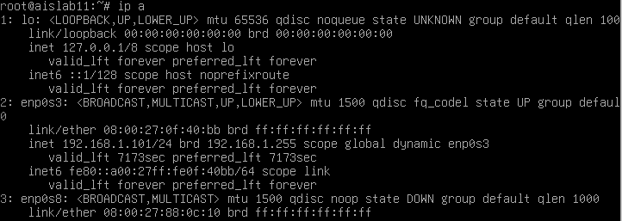

ip a после ip link set dev enp0s8 up

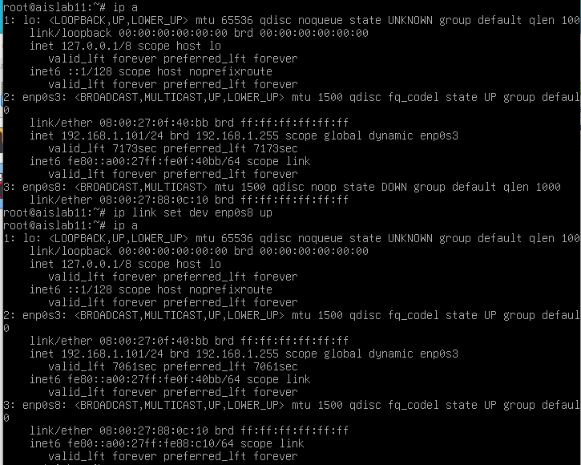

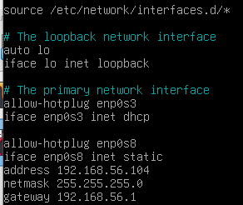

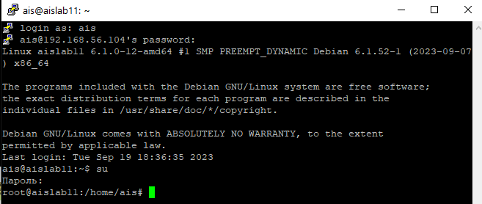

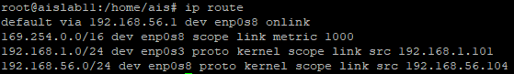

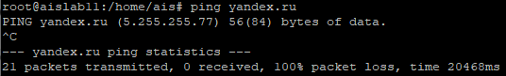





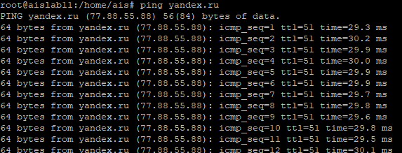

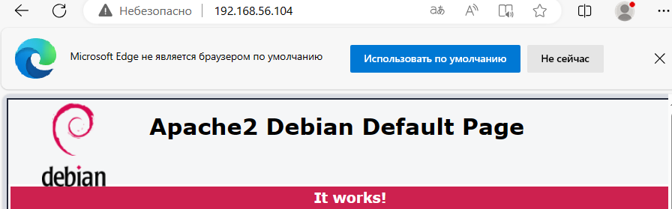

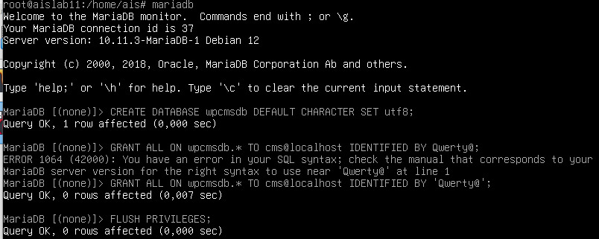

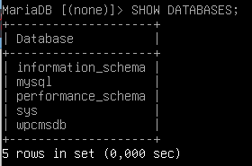

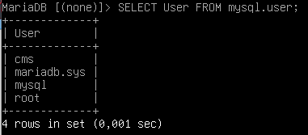



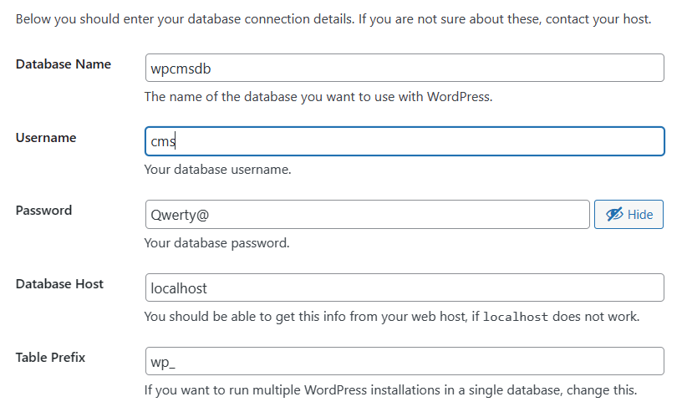

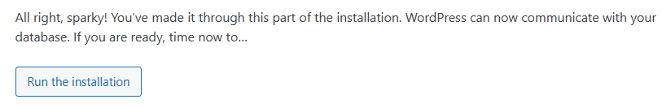

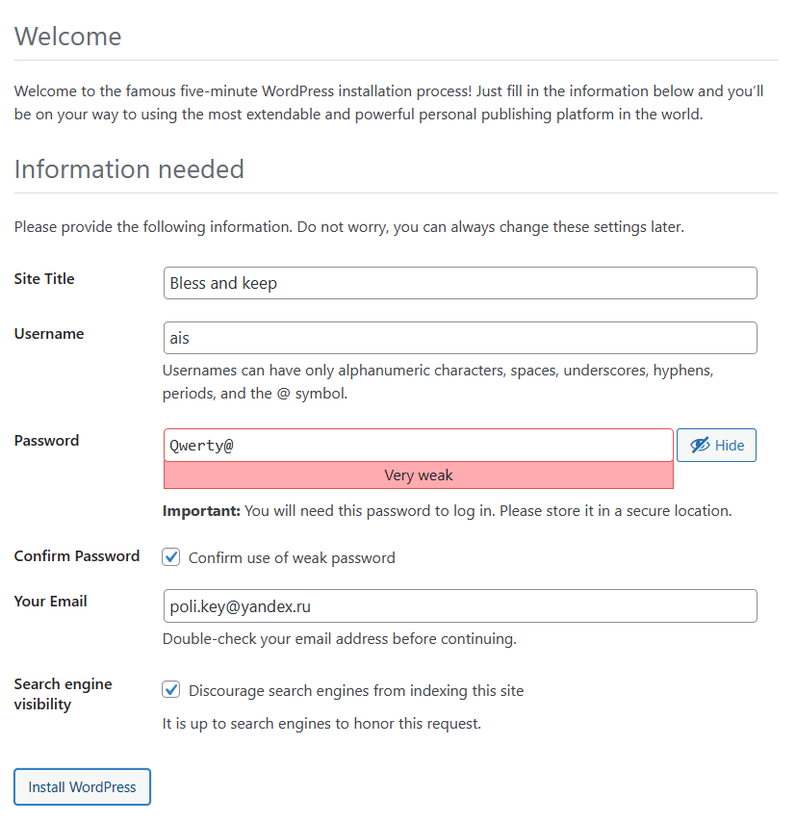

Our group decided to make the site using framework Django.



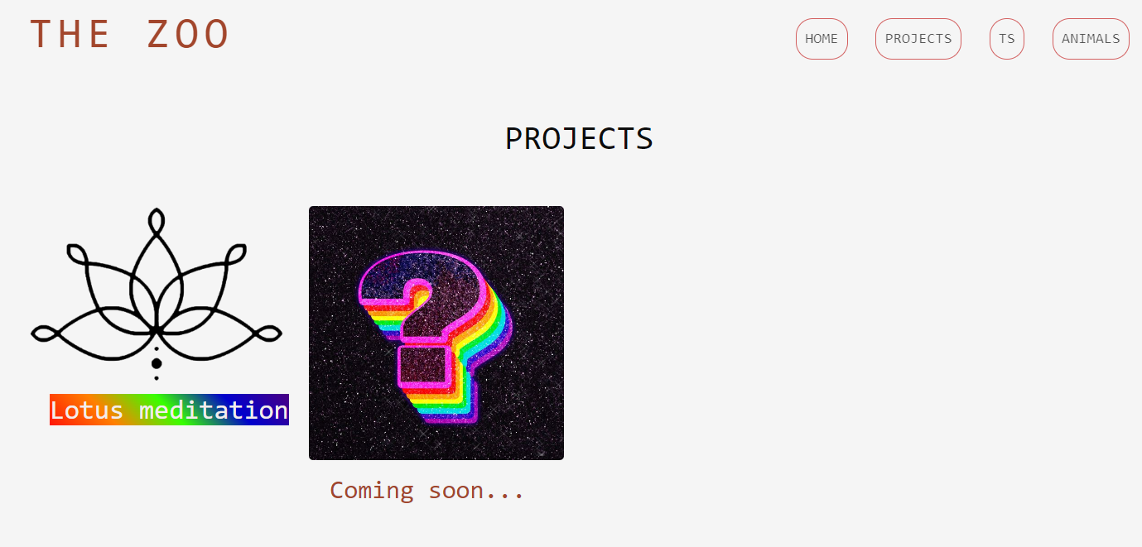

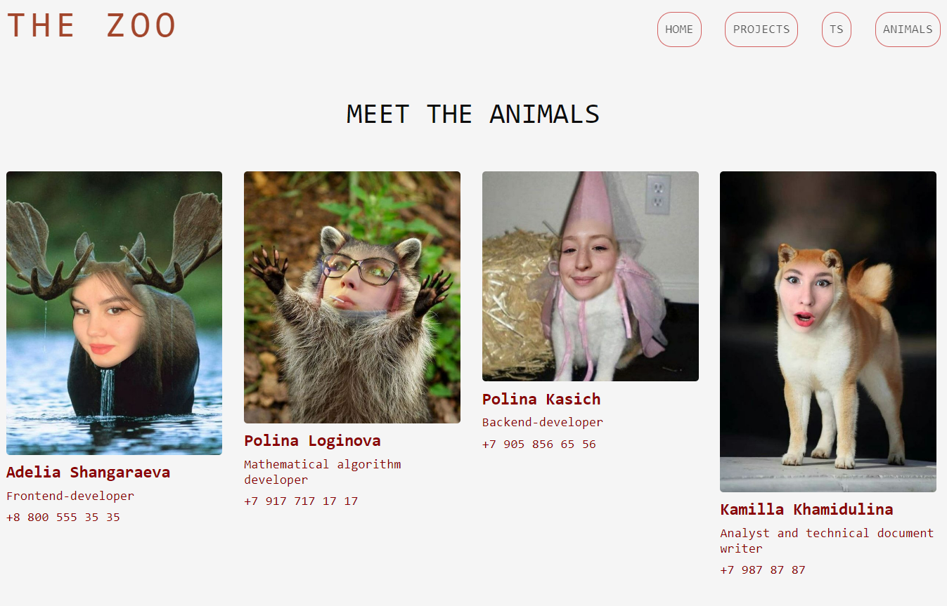

# Bibliography

1. Theoretical part
   1. <https://www.seonews.ru/glossary/cms/>
   2. <https://ru.wikipedia.org/wiki/%D0%A1%D0%B8%D1%81%D1%82%D0%B5%D0%BC%D0%B0_%D1%83%D0%BF%D1%80%D0%B0%D0%B2%D0%BB%D0%B5%D0%BD%D0%B8%D1%8F_%D1%81%D0%BE%D0%B4%D0%B5%D1%80%D0%B6%D0%B8%D0%BC%D1%8B%D0%BC>
   3. <https://yasoldat.ru/cms-ili-cmf-v-chem-raznitsa/>
   4. <https://druki.ru/wiki/drupal/releases>